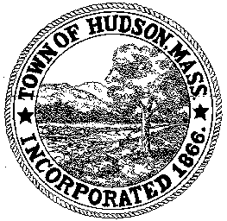

CONSERVATION COMMISSION
78 Main Street, Hudson, MA 01749
(978) 562-2020

Paul Byrne, Chairman W. Minot Wood, Vice Chairman David Esteves, Member

Terrence Joyce, Member Leif Longtine, Member Joseph Rodrigues, Member Al Tashian, Member

Meeting Agenda
May 19, 2011 7:00 P.M.

- Preliminaries
  - Open Meeting
  - Roll Call

2.0 New Business
2.1 RDA 408
Location: 14 Lakeshore Drive
Applicant: Andrea Wertheim
Project Description: Remove existing deck and stairs and construct a 10’ x 16’ deck with stairs

2.2 422 Main Street
2.3 Minutes May 5, 2011
2.4 Beaver Traps

3.0 Old Business

4.0 Correspondence
4.1 MA Conservation Mapping Assistance Partnership Program

5.0 Adjournment:

Next Meeting: June 2, 2011

